**ROTARACT DISTRICT ORGANISATION 3150**

**July 1st Service Activity**

|  |  |  |
| --- | --- | --- |
| **Service Activity** | **No. Of members participated** | **No of Beneficiaries/Count of Donation made** |
| Donate a Dustbin |  |  |
| Plant a Sapling | **3** | **3** |
| Meal Distribution | **2** | **15** |
| Ration Kit Distribution |  |  |
| Feed Stray Animals | **1** | **5** |
| Masks & Sanitisers Distribution | **1** | **20** |
| Clothes/Blankets Distribution |  |  |

**Activity 1**

**Short description: Plant a Sapling**

**On 1st  july Rtr.Hrushinath (president), Rtr.Tarun Kotagiri (international service director), Rtr.Meghana Sharon (sergeant at arms) planted saplings in nearby their home gardens and in flowerpots.**

**Date: 01-07-2021**

**Photos:** (Collages are highly recommended)

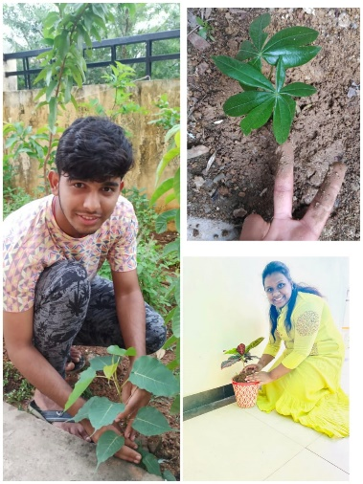

**Social Media Link:**

[**https://instagram.com/kgrcet_rotaractors?utm_medium=copy_link**](https://instagram.com/kgrcet_rotaractors?utm_medium=copy_link)

**Activity 2**

**Short description: Meal Distribution**

**On the day of performing service activities/tasks our team distributed meals to the needy or privileged people who cannot afford the proper meal or food.**

**Rtr.Shivani Gupta (secretary) and Rtr.Sonal Singh (cultural service director) took part in this activity and served the needy through their service.**

**Date: 01-07-2021**

**Photos:** (Collages are highly recommended)

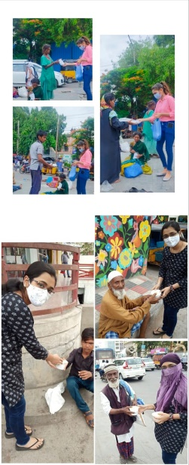

**Social Media Link:**

[**https://instagram.com/kgrcet_rotaractors?utm_medium=copy_link**](https://instagram.com/kgrcet_rotaractors?utm_medium=copy_link)

**Activity 3**

**Short description: Feed Stray Animals**

**Rtr.Tarun Kotagiri (international service director) took part in this activity and fed peacocks in nearby his home.**

**Date: 01-07-2021**

**Photos:** (Collages are highly recommended)

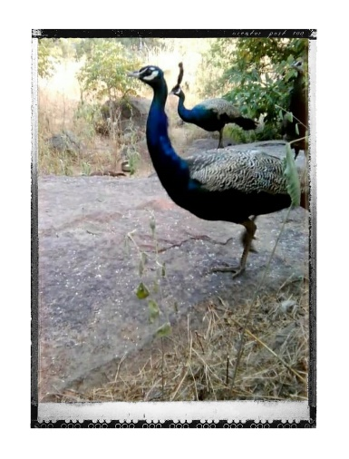

**Social Media Link:**

[**https://instagram.com/kgrcet_rotaractors?utm_medium=copy_link**](https://instagram.com/kgrcet_rotaractors?utm_medium=copy_link)

**Activity 4**

**Short description: Masks and Sanitizers**

**Rtr.G.Nikhil (Membership Development Director) took part in this community service,…distributed masks to the people in nearby his home and some areas.**

**Date: 01-07-2021**

**Photos:** (Collages are highly recommended)

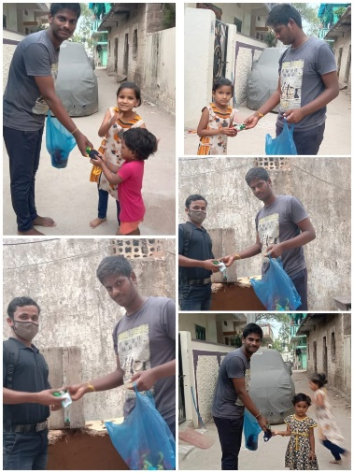

**Social Media Link:**

[**https://instagram.com/kgrcet_rotaractors?utm_medium=copy_link**](https://instagram.com/kgrcet_rotaractors?utm_medium=copy_link)